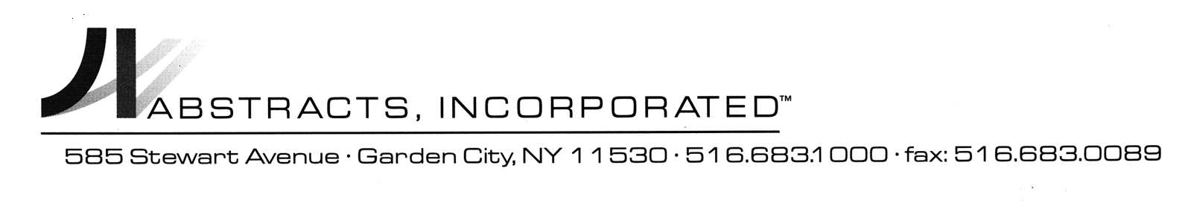

RELEASE AND DISCHARGE OF MECHANIC’S LIEN

TO: The Clerk of the County of , State of New York, and all others interested.

PLEASE TAKE NOTICE, that , Lienor, had and claimed a Mechanic’s Lien pursuant to the Lien Law of the State of New York, which Lien was filed with the Office of the Clerk of the County of on , 20 against the real property known as and designated as tax block , lot no. , a copy of which Lien is annexed hereto.

PLEASE TAKE FURTHER NOTICE, that , Lienor hereby consents to the release and discharge of the aforesaid Mechanic’s Lien and directs that the Clerk of the County of discharge said Mechanic’s Lien of record.

Dated: , New York
, 20 . LIENOR
________________________________

Sworn to before me this

___________day of ______________ 20__

